

REACT JS PROJECT REPORT ON
Restaurant Ordering System

Submitted by
APARNA KL
24BIT105

Under the Guidance of
Mr.Aravind
Technical Trainer
Technical Department, KG College of Arts and Science

Academic Year: 2025 – 2026
APRIL 2026

DECLARATION
I hereby declare that the project entitled “Restaurant Ordering System” submitted in partial fulfillment of the requirements for the course Reactjs is a record of my original work carried out under the guidance of [Trainer Name], Technical Trainer, Technical Department, KG College of Arts and Science.
I further declare that this project has not been submitted previously, either in part or in full, for the award of any degree, diploma, or other similar title, at this or any other institution.
I have acknowledged all sources of information used in this project wherever applicable.

April 2026
Coimbatore

KL APARNA

CERTIFICATE
This is to certify that the project entitled “Restaurant Ordering System” is a bona fide work carried out by KL Aparna, II/B, Department of Information Technology KG College of Arts & Science, in partial fulfillment of the requirements for the course Reactjs.
This project has been completed under my supervision and guidance during the academic period April 2026.

Place: Saravanampatti
Date:

Submitted for the Viva-Voce Examination held on 09/04/2026

Guide: Head of the Department
(Technical Trainer, KGCAS) (Technical Head, KGCAS)

______________________ _______________________

TABLE OF CONTENTS
S. No. | Topics | Page. No.
1 | Introduction
1.1 | Background of the Study
1.2 | Problem Statement
1.3 | Objectives of the Project
1.4 | Purpose and Significance
1.5 | Scope and Limitations
1.6 | Methodology Overview
2 | System Analysis
2.1 | Existing System
2.2 | Drawbacks of the Existing System
2.3 | Proposed System
2.4 | Features of the Proposed System
2.5 | Feasibility Study
2.6 | Requirement Analysis
3 | System Design
3.1 | System Architecture
3.2 | Use Case Diagram
3.3 | Data Flow Diagram (DFD)
3.4 | Entity Relationship Diagram (ERD)
3.5 | User Interface Design
4 | System Implementation
4.1 | Development Tools
4.2 | Module Description
4.3 | Algorithms
4.4 | System Integration
4.5 | Security and Validation
5 | System Testing
5.1 | Testing Methodology
5.2 | Test Cases
5.3 | Error Handling
5.4 | Performance
6 | Input and Output Screens
6.1 | System Outputs
6.2 | Discussion
6.3 | Comparison
6.4 | User Feedback
7 | Conclusion and Future Enhancement
7.1 | Summary
7.2 | Limitations
7.3 | Future Scope
8 | References
Appendices
- Source Code Snippets
- Screenshots of Web Pages

ABSTRACT
The Educational Website project is a web-based application designed to provide an interactive platform for online learning. It allows students to access course materials, lessons, and quizzes through an intuitive and responsive interface. The system is developed using HTML, CSS, and JavaScript, ensuring cross-platform compatibility and ease of use.
The project aims to simplify the process of learning by offering categorized content, self-assessment through quizzes, and real-time feedback. JavaScript is used extensively for dynamic content rendering, input validation, and interactive user experiences. The modular structure ensures scalability for future integration of databases, user authentication, and content management systems.
This project demonstrates how web technologies can effectively support e-learning by creating a structured, user-friendly environment that enhances engagement and accessibility. It serves as a foundation for future enhancements such as video tutorials, AI-based recommendations, and certificate generation.

Chapter 1: Introduction
  - Background of the Study
In the modern era, technology has transformed the way businesses operate, especially in the food and restaurant industry. Traditional restaurant ordering methods are now being replaced by digital systems that improve efficiency and customer experience. A Restaurant Ordering System acts as a digital platform that allows customers to view menus, select items, and place orders easily from anywhere within the restaurant or online. Using web technologies such as HTML, CSS, and JavaScript (ReactJS), this project aims to create an interactive and responsive application that enhances ordering convenience and reduces manual effort.
1.2 Problem Statement
Customers and restaurant staff often face challenges with traditional ordering methods, such as long waiting times, incorrect orders, and inefficient service management. Many existing restaurant systems are complex, costly, or not user-friendly. Therefore, there is a need for a simple, efficient, and easy-to-use Restaurant Ordering System that provides a digital menu, smooth navigation, and real-time order management to improve overall service quality.
1.3Objectives of the Project
- To design and develop an interactive Restaurant Ordering System using ReactJS.
- To provide a structured digital menu with categorized food items.
- To implement a cart system for placing and managing orders.
- To ensure the application is responsive and accessible on multiple devices.
- To demonstrate dynamic functionality using JavaScript for real-time interaction.
1.4 Purpose and Significance of the Study
The main purpose of this project is to improve the restaurant ordering process through a digital platform. It helps customers place orders quickly and accurately while reducing workload and errors for restaurant staff. This system supports modern digital solutions in the food industry and enhances customer satisfaction through a smooth and efficient ordering experience.

1.5 Scope and Limitations
Scope:
The project focuses on developing the front-end of a Restaurant Ordering System with modules for displaying the menu, selecting food items, and managing orders through a cart system. The application provides an interactive interface for users to browse categories and place orders easily.
Limitations:
This version does not include database connectivity, payment integration, or user authentication. Future versions can include backend services, real-time order tracking, admin panel for restaurant management, and secure online payment options.
1.6 Methodology Overview
The project follows a structured Software Development Life Cycle (SDLC) approach consisting of Requirement Analysis, Design, Development, Testing, and Implementation. The tools used include Visual Studio Code, HTML5, CSS3, and JavaScript (ReactJS) for developing an interactive and responsive Restaurant Ordering System.

Chapter 2: System Analysis
2.1 Existing System
In the existing restaurant setup, customers rely on manual ordering methods such as reading printed menus and placing orders through waiters. These systems often lack efficiency, real-time updates, and proper order tracking. Traditional methods can lead to delays, miscommunication, and limited flexibility in managing orders.
2.2 Drawbacks of the Existing System
· Ordering process is time-consuming and may cause delays.
· High chances of order miscommunication between customers and staff.
· No real-time updates on order status.
· Manual handling of orders increases workload for staff.
· Difficult to manage and update menu items efficiently.
2.3 Proposed System
The proposed Restaurant Ordering System provides an interactive web-based platform where customers can browse the menu, select food items, and place orders digitally. The system uses HTML, CSS, and JavaScript (ReactJS) to create a responsive and user-friendly interface. Orders are managed through a cart system, allowing users to add, remove, and view items dynamically. This system reduces manual errors and improves overall service efficiency.
2.4 Features of the Proposed System
- Responsive and interactive user interface.
- Categorized digital menu with clear navigation.
- Add-to-cart and order management functionality.
- Dynamic updates using JavaScript (ReactJS).
- Easy to extend with features like payment integration and order tracking.
2.5 Feasibility Study
Technical Feasibility:
The project uses lightweight and open-source technologies such as HTML5, CSS3, and JavaScript (ReactJS), ensuring easy development and compatibility across devices.
Economic Feasibility:
The development cost is minimal as it uses free tools and does not require licensed software for the prototype version.
Operational Feasibility:
The system is simple, user-friendly, and does not require special training, making it easy for both customers and restaurant staff to use.
2.6 Requirement Analysis
Functional Requirements:
Functional Requirements:
- Display menu items with categories.
- Allow users to add, remove, and manage items in the cart.
- Show order details dynamically.
- Provide responsive design for different devices.
Non-Functional Requirements:
- Fast loading and smooth performance.
- User-friendly interface and easy navigation.
- Scalability for future enhancements.
- Maintainability and flexibility of the system.

Chapter 3: System Design
3.1 Introduction
System design defines the overall architecture, structure, and workflow of the Restaurant Ordering System. It translates the requirements identified in the analysis phase into a structured design for implementation. The design focuses on the interaction between users, the menu interface, and the cart system to ensure a smooth and efficient ordering experience.
3.2 System Architecture
The system follows a three-layer architecture — Presentation Layer (Frontend), Application Logic Layer, and Data Layer.

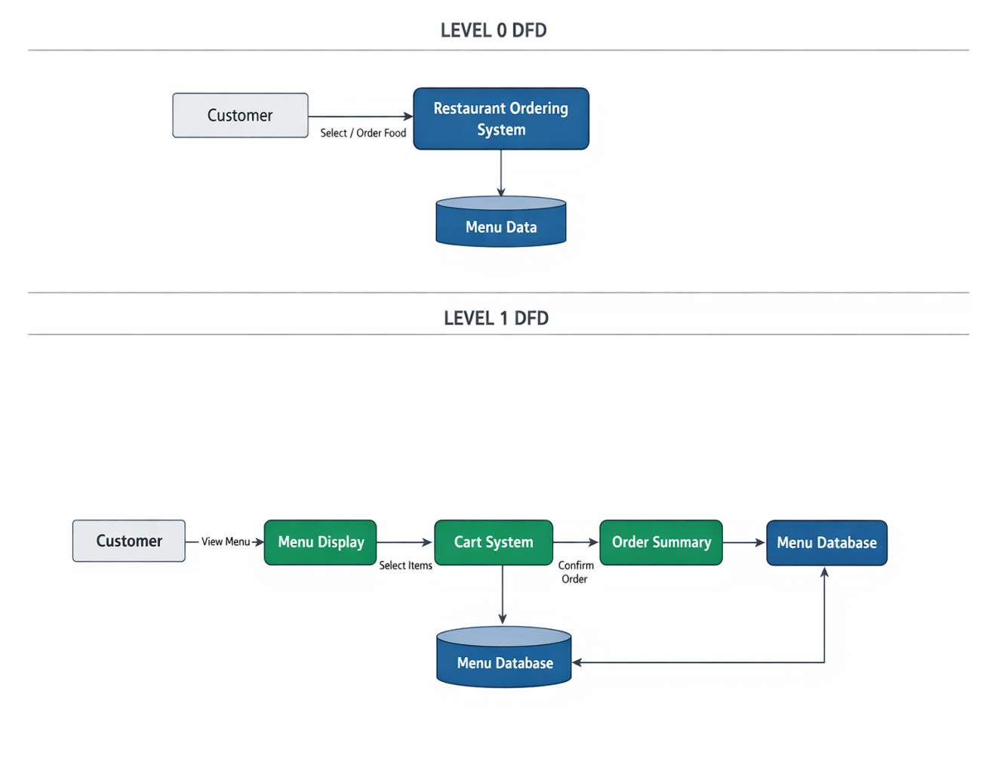

Description:
• Presentation Layer: Displays menu and handles user interaction.
· Application Layer: Processes logic like cart and order handling.
· Data Layer: Stores menu and order data using JSON/localStorage.

3.3 Use Case Diagram

1. What is a Use Case Diagram?
A Use Case Diagram visually shows how users interact with the Restaurant Ordering System.
- Actors → The users interacting with the system (e.g., Customer).
- Use Cases → The actions performed (e.g., view menu, add to cart, place order).
- Relationships → The connection between users and system actions.
It helps to explain “Who does what” in the Restaurant Ordering System.

2. Identify the Main Actors (for your Educational Website)
Actor | Description
Customer/User | The main actor who views the menu, selects food items, adds them to the cart, and places orders.
Administrator (optional) | Manages menu items, categories, and updates food details.
Staff (optional) | Handles order processing and monitors customer orders.

3. Identify the Main Use Cases

For Customer/User
- Register / Login (if implemented)
- View Menu
- Select Food Items
- Add Items to Cart
- Remove / Update Items in Cart
- Place Order
- View Order Summary

For Administrator
- Login to Admin Panel
- Add / Edit / Delete Menu Items
- Manage Food Categories
- View and Manage Orders
4. Define Relationships
Symbol | Meaning
Solid line | Association (Actor performs a use case)
<<include>> | A mandatory sub-task inside another use case
<<extend>> | An optional or conditional task
Example:
· “Place Order” <<include>> “Add to Cart”
· “Place Order” <<include>> “View Order Summary”
· “Apply Offer” <<extend>> “Place Order”

5. Draw the Diagram (Structure Example)
Tools you can use:
· draw.io, Lucidchart, StarUML, MS Visio
· Draw actors (Customer, Admin)
· Draw system box (Restaurant Ordering System)
· Add use cases (View Menu, Add to Cart, Place Order)
· Connect with lines and use <<include>> / <<extend>>

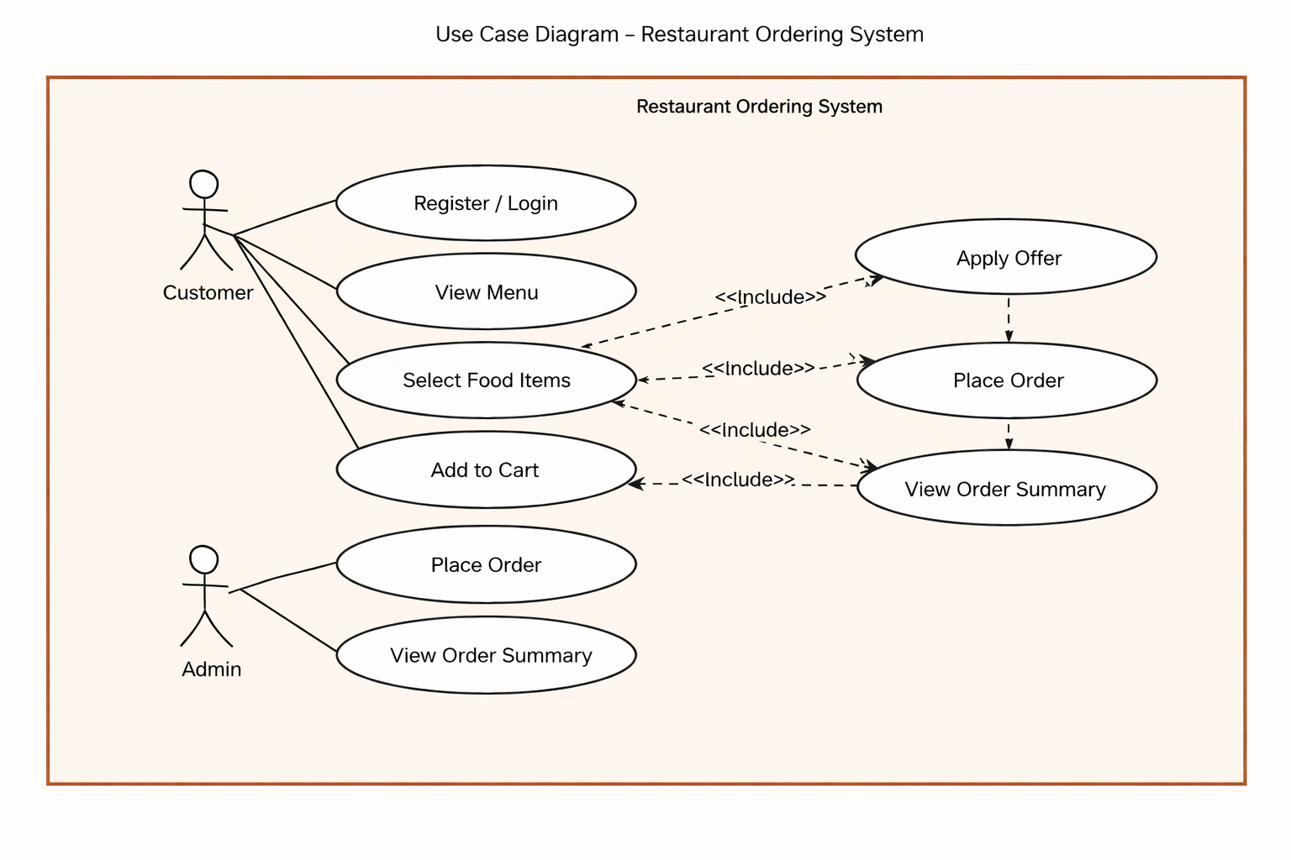

6. Example Explanation (Text Description)
Actors:
- Customer: The user who interacts with the system to view menu and place orders.
- Administrator: The manager who controls menu items and manages orders.
Use Cases:
- View Menu: Customer browses available food items.
- Select Food Items: Customer chooses items from the menu.
- Add to Cart: Customer adds selected items to the cart.
- Place Order: Customer confirms and places the order.
- View Order Summary: Customer checks order details and total price.
- Apply Offer (optional): Customer applies discounts if available.
7.Manage Menu (Admin): Add, edit, or delete food items.
8.Manage Orders (Admin): View and handle customer orders.

7. Step-by-Step (Using draw.io)
- Go to https://app.diagrams.net
- Choose a blank diagram → name it “Use Case Diagram”
- From the left panel, drag:
  - Stick figures → represent Actors (Customer, Admin)
  - Ovals → represent Use Cases (View Menu, Add to Cart, Place Order, etc.)
  - Box → system boundary (“Restaurant Ordering System”)
- Connect Actors ↔ Use Cases using lines
- Label relationships (<<include>> / <<extend>>) where needed
- Export as .PNG / .JPG and insert into your documentation

3.4 Data Flow Diagram (DFD)

1. What is a Data Flow Diagram (DFD)?
A Data Flow Diagram shows how data moves through the Restaurant Ordering System —
from inputs → processes → outputs → data stores.
It helps you visualize:
- Where the data comes from (Customer input)
- What processes handle it (menu selection, order processing)
- Where it is stored (menu data / order data)
- Where it goes (order confirmation/output)
2. DFD Symbols You’ll Use
Symbol | Meaning
Rectangle | External Entity (e.g., Customer, Admin)
Circle / Rounded Rectangle | Process (e.g., “Select Food”, “Process Order”)
Two Parallel Lines | Data Store (e.g., “Menu Data”, “Order Data”)
Arrow | Data Flow (shows direction of data movement)
3. Levels of DFD
Level 0 — Context Diagram (Top Level)
Shows the entire Restaurant Ordering System as a single process and its interaction with external entities like Customer.
Level 1 — Decomposition
Breaks the main system into sub-processes such as menu display, cart management, and order processing.
Level 2 — Detailed Level
Further breaks down complex processes (optional for small projects).

4.Steps to Create a DFD
Step 1: Identify External Entities
- Customer/User
- Administrator
Step 2: Identify Main Processes
· Display Menu
· Select Food Items
· Manage Cart
· Process Order
· Manage Menu (Admin)
Step 3: Identify Data Stores
· Menu Data Store
· Cart Data
· Order Data
Step 4: Identify Data Flows
· “Request Menu”
· “Food Item Details”
· “Cart Items”
· “Order Confirmation”

5. DFD for Educational Website
Level 0: Context Diagram
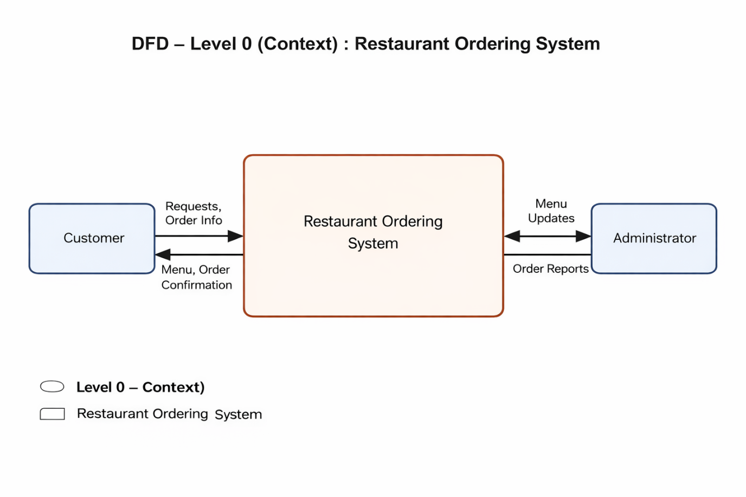
Explanation:
- Student interacts with the system to view courses, read lessons, and take quizzes.
- Admin updates and manages course and quiz content.

Level 1: Detailed System View
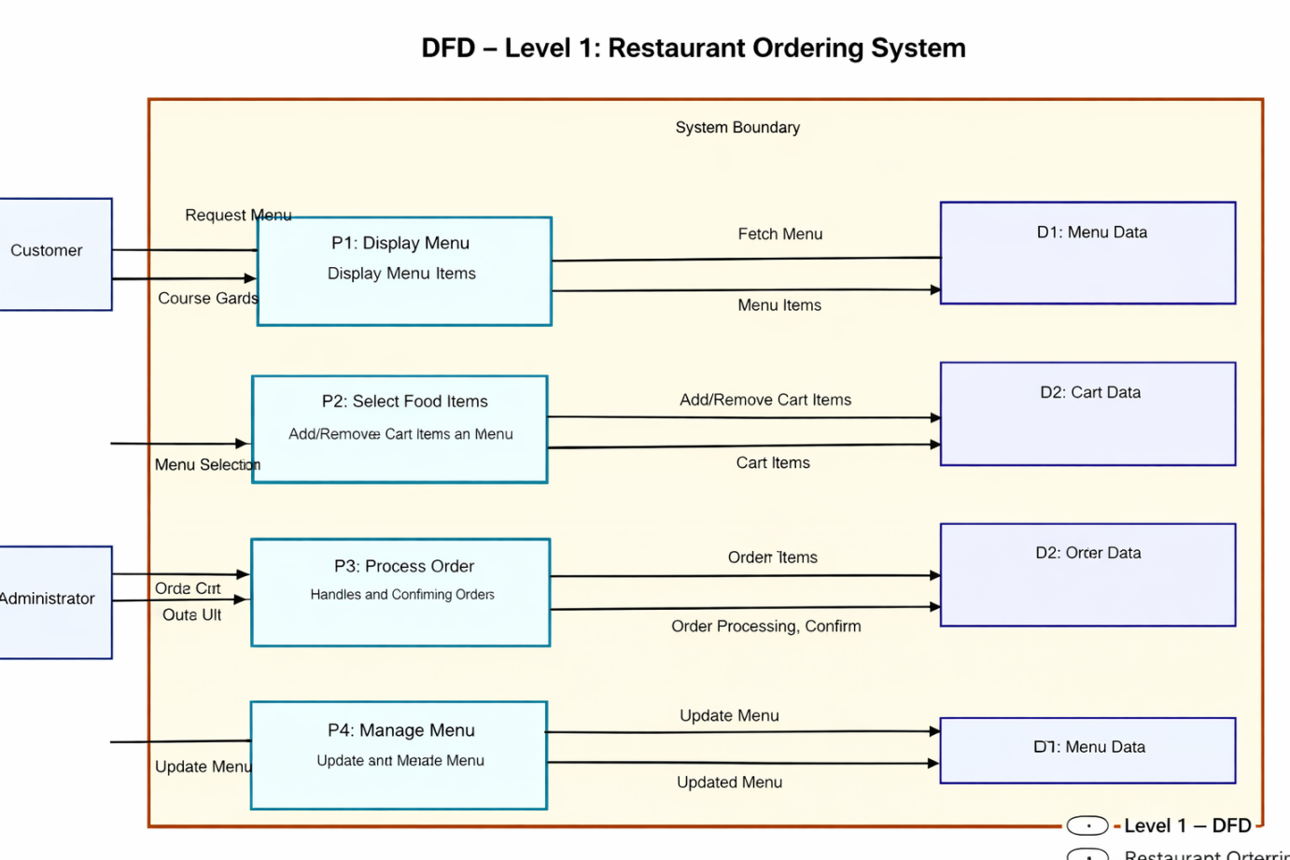
Explanation:
- Process P1: Fetches menu items from the Menu Data Store.
- Process P2: Handles selection of food items and manages cart data.
- Process P3: Processes customer orders and stores them in Order Data Store.
- Process P4: Manages menu updates (add/edit/delete) in Menu Data Store.

Level 2: Quiz Process (Example Sub-process)
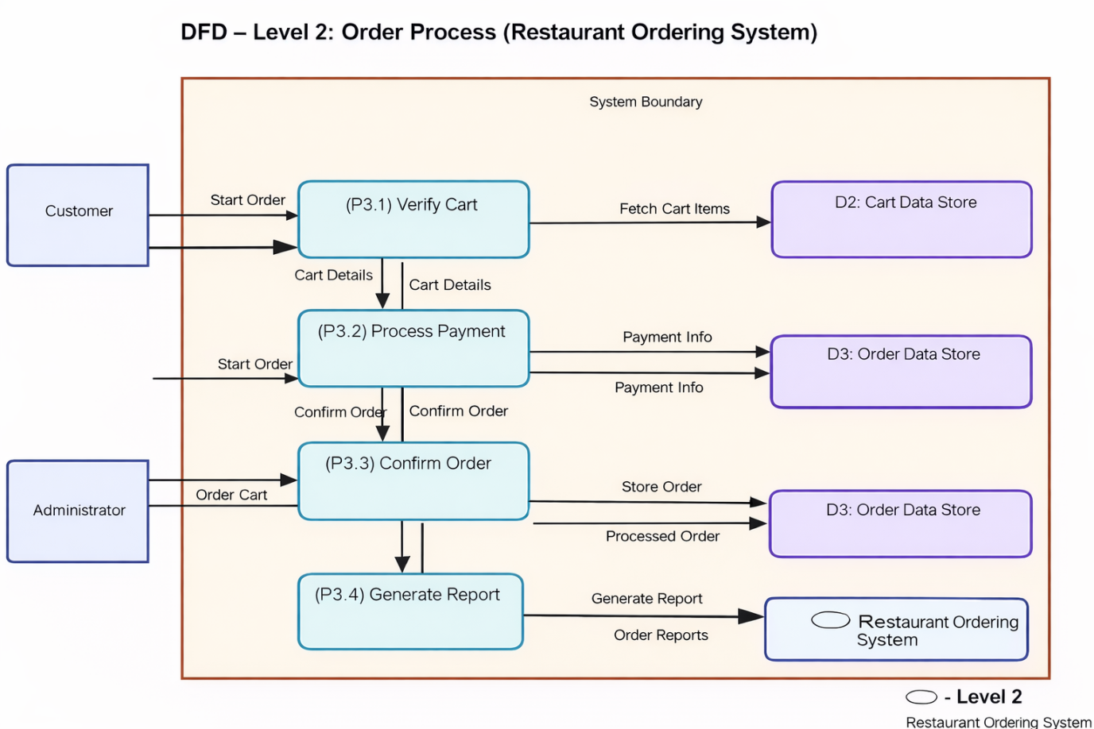
6. Tools to Draw Your DFD
Free, easy online tools:
- https://app.diagrams.net (recommended)
- Lucidchart
- Creately
- StarUML
- Microsoft Visio
Steps (in draw.io):
· Go to https://app.diagrams.net
· Choose Blank Diagram → name it “DFD_RestaurantOrderingSystem”
· Use:
- Rounded rectangles → processes
- Parallel lines → data stores
- Rectangles → external entities
- Arrows → data flow
· Label everything clearly (arrows = data names)
· Export as .PNG / .JPG and insert into your report.
3.5 Entity Relationship Diagram (ERD)
Entities and Relationships:
- Menu (Menu_ID, Item_Name, Description, Price, Category)
- Cart (Cart_ID, Menu_ID, Quantity, Total_Price)
- Order (Order_ID, Cart_ID, Total_Amount, Order_Status)
Relationships:
• A Menu Category can have many Menu Items.
· A Customer can place multiple Orders.
· An Order can contain multiple Menu Items.
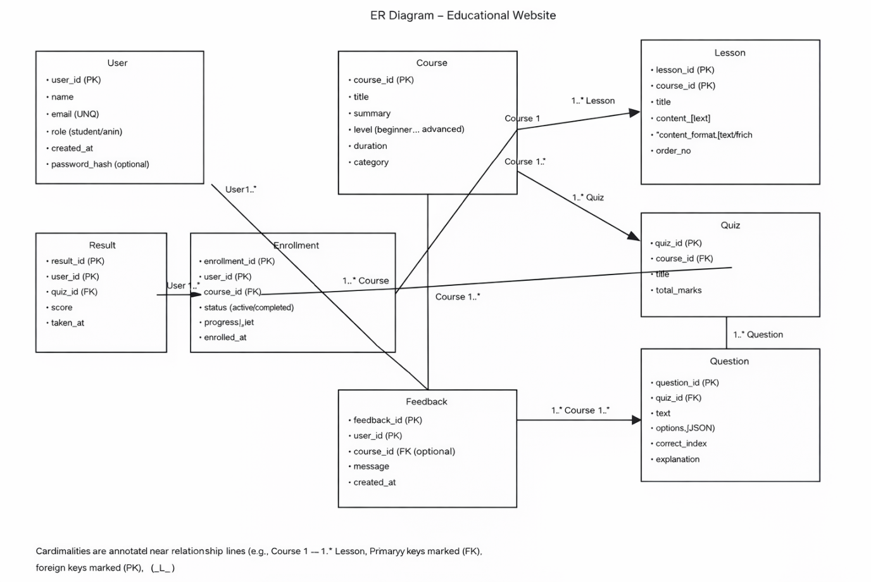
3.6 User Interface Design
The UI is designed to be simple, responsive, and user-friendly. It uses HTML for structure, CSS/Bootstrap for styling, and JavaScript (ReactJS) for interactivity.

Main Pages:
- Homepage: Displays available menu items and categories.
- Menu Page: Shows food items with options to add to cart.
- Cart Page: Displays selected items, quantity, and total price.
- Order Page: Shows order summary and confirms the order.
(Insert wireframe sketches or screenshots of each page.)

Chapter 4: System Implementation
4.1 Introduction
System implementation is the stage where the design is converted into a working web application. This phase involves coding, integrating different modules, testing functionality, and ensuring that the system works efficiently.
The Restaurant Ordering System is implemented using front-end technologies such as HTML, CSS, and JavaScript (ReactJS) to provide an interactive, responsive, and user-friendly ordering platform.
4.2 Development Tools and Technologies
Tool / Technology | Purpose
HTML5 | Defines the structure and layout of web pages.
CSS3 / Bootstrap | Adds style, layout design, and responsive.
JavaScript (ES6) | Implements interactivity, cart management,dynamic updates.
Visual Studio Code | Code editor for development and testing.
Browser (Chrome / Edge) | Used for execution and debugging the application.
LocalStorage / JSON | Stores menu items, cart data, and order details locally.
4.3 System Modules Description
Module | Description
Home Module | Displays available menu items with categories and details.
Menu Module | Allows users to view food items and select them.
Cart Module | Manages selected items, quantity, and total price.
Order Module | Allows users to give feedback or suggestions.
Each module is interconnected using JavaScript/ReactJS functions, ensuring smooth navigation and efficient state management within the application.

4.4 Implementation Details
The implementation follows a modular approach:
- Frontend Design:
The user interface is developed using HTML for structure and CSS/Bootstrap for styling to create an attractive and responsive layout.
- Dynamic Behavior:
JavaScript (ReactJS) is used to dynamically display menu items, update the cart, and reflect changes in real-time.
- Event Handling:
User actions such as adding items to cart, removing items, and placing orders are handled using event listeners (e.g., onClick).
- Order Processing Logic:
When the user places an order, the system calculates the total amount, updates cart details, and displays the order summary instantly.
- Data Management:
Data such as menu items, cart details, and orders are stored and retrieved using LocalStorage or JSON for temporary persistence.

4.5 Algorithm / Logic of Core Function

Algorithm for Order Processing:
- Initialize total amount = 0.
- Loop through all items in the cart.
- For each item:
  - Multiply price × quantity.
  - Add result to total amount.
- Display the total amount.
- Confirm order and store details (optional).

Algorithm for Dynamic Menu Display:
- Retrieve menu items from JSON data.
- Loop through all menu items.
- Use DOM/React rendering to display item name, price, and details.
- Allow user to click “Add to Cart” button.
- Update cart dynamically when items are added.

4.6 Security and Validation
- Input validation is implemented using JavaScript to prevent invalid or empty inputs (e.g., quantity selection).
- Only valid cart and order data are processed.
- The system uses LocalStorage, ensuring no sensitive data is transmitted externally.
- Error handling is implemented using alerts and conditional checks (e.g., empty cart warning).
4.7 Integration
All modules are seamlessly integrated using event-driven programming. Navigation between the homepage, menu page, cart, and order summary is handled through JavaScript/ReactJS, ensuring smooth interaction without page reloads.
4.8 Output Screens (Snapshots)
Include labeled screenshots for:
- Homepage – list of menu items and categories.
- Menu Page – food items with “Add to Cart” option.
- Cart Page – selected items with total price.
- Order Page – order summary and confirmation.

Chapter 5: System Testing
5.1 Introduction
System testing is a crucial phase that ensures the developed application meets all functional and non-functional requirements. It verifies whether the system performs correctly under different conditions.
For the Restaurant Ordering System, testing was conducted to validate the functionality of modules such as menu display, item selection, cart management, order processing, and order summary generation.
5.2 Objectives of Testing
- To ensure that all modules (Home, Menu, Cart, Order) function correctly.
- To identify and fix any logical or runtime errors in the system.
- To confirm that user actions (adding items, placing orders) produce correct outputs.
- To verify that the application works smoothly across different browsers and devices.

5.3 Types of Testing Performed
a) Unit Testing
Each JavaScript/ReactJS function and component was tested independently. For example, functions handling cart operations, total calculation, and localStorage data were verified.
b) Integration Testing
All modules were combined and tested to ensure smooth navigation between pages (Home → Menu → Cart → Order) without errors.
c) System Testing
The complete application was tested to ensure all functionalities such as menu display, cart management, order processing, and responsiveness worked correctly.
d) User Acceptance Testing (UAT)
The system was tested by users to gather feedback. The application’s design, usability, and performance were reviewed, and improvements were made accordingly.
e) Cross-Browser and Device Testing
The system was tested on browsers like Google Chrome, Mozilla Firefox, and Microsoft Edge, and on devices such as laptops and mobile phones to ensure responsiveness.
5.4 Test Plan
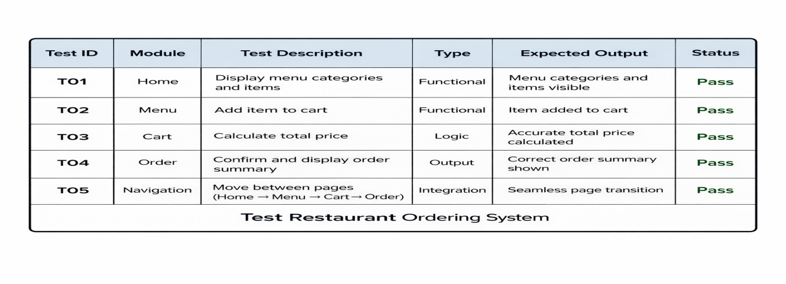
5.5 Test Data and Execution
Sample data were created in JSON format for menu items and orders. JavaScript/ReactJS functions were executed to ensure they correctly retrieved and displayed menu details, cart items, and order summaries dynamically. The output was verified by comparing expected results with actual results.

5.6 Error Handling
• Input validation ensures that invalid actions (e.g., empty cart or invalid quantity) are not processed.
· Errors in data handling or application logic are managed using conditional checks and try-catch statements.
· Clear alert messages are displayed to guide the user (e.g., “Cart is empty”, “Please select items”).
5.7 Performance and Usability Testing
· Performance: Page load time was under 2 seconds in standard browsers.
· Usability: Users found the system easy to navigate, visually clear, and user-friendly.
· Accessibility: The application supports basic accessibility features like readable fonts and responsive design for different devices.

5.8 Results and Observations
All modules functioned as expected. The application performed well across multiple devices, and user feedback confirmed that it was interactive, efficient, and easy to use. No critical defects were identified during the final testing phase.

Chapter 6: Results and Discussion
6.1 Introduction
This chapter presents the practical results obtained after implementation and testing. It demonstrates how each module of the Restaurant Ordering System performed during execution and how effectively the system met its objectives.
6.2 System Outputs
During execution, the system produced the following key results:
- Homepage: Displayed menu items with names, categories, and prices.
- Menu Page: Loaded food items dynamically without page refresh.
- Cart Page: Allowed users to add, remove, and update items with real-time total calculation.
- Order Page: Displayed order summary with total amount and confirmation.
All pages were verified to be responsive and accessible across desktop and mobile browsers.
6.3 Performance Analysis
· Responsiveness: Average page load time was under 2 seconds.
· Accuracy: Order total calculation and cart operations achieved 100% accuracy.
· Stability: No runtime or data-handling errors during repeated testing.
· Cross-Browser Compatibility: Verified on Chrome, Edge, and Firefox with consistent performance.
6.4 User Feedback
A small group of users tested the prototype. Feedback indicated:
- Simple and intuitive navigation.
- Clean and user-friendly interface for menu and cart.
- Interest in additional features like login, online payment, and order tracking in future versions.

Chapter 7: Conclusion and Future Enhancement
7.1 Conclusion
The Restaurant Ordering System project demonstrates how modern web technologies can be used to create a simple and user-friendly food ordering platform. Using HTML, CSS, and JavaScript (ReactJS), the system allows users to browse menu items, add them to the cart, and place orders efficiently.
All modules functioned correctly during testing, ensuring smooth performance, usability, and responsiveness. This project serves as a strong foundation for developing advanced restaurant management systems in the future.
7.2 Limitations
While the system meets its core objectives, it has some limitations:
- No user authentication or login system.
- Uses LocalStorage/JSON instead of a real database.
- No online payment integration.
- Limited order tracking and history features.
7.3 Future Enhancement
The system can be improved with the following enhancements:
- Database Integration: Connect with MySQL or MongoDB for storing menu and order data.
- User Accounts: Add login and registration features for customers.
- Admin Panel: Allow admins to manage menu items, prices, and orders dynamically.
- Online Payment: Integrate payment gateways (UPI, cards, etc.).
- Order Tracking: Provide real-time order status updates.
- Cloud Deployment: Host the application on platforms like AWS or Firebase.
- Mobile App Version: Develop an Android/iOS app for better user experience.

Chapter 8: References
8.1 Books & Journals
· Web Technologies: HTML, CSS, JavaScript, PHP, Java, JSP, XML, and AJAX — Uttam K. Roy, Oxford University Press.
· Learning Web Design — Jennifer Niederst Robbins, O’Reilly Media.
· Modern Web Development Concepts and Applications — Relevant academic sources for web application development.
8.2 Online Resources
· MDN Web Docs — https://developer.mozilla.org
· W3Schools — https://www.w3schools.com
· Bootstrap Official Documentation — https://getbootstrap.com
· JavaScript.info Tutorials — https://javascript.info
· FreeCodeCamp Tutorials — https://www.freecodecamp.org
· GeeksforGeeks Web Development Articles — https://www.geeksforgeeks.org
8.3 Tools & Frameworks Used
· Editor: Visual Studio Code
· Languages: HTML5, CSS3, JavaScript (ES6), ReactJS
· Framework: Bootstrap 5 (for responsive UI)
· Database (Future Scope): JSON / MySQL
· Browser: Google Chrome / Microsoft Edge

Appendices

Appendix A – Source Code
Include your main source files:
- index.html — Homepage and overall structure.
- style.css — Styling and responsive layout.
- script.js / React Components — Core logic for menu display, cart management, and order processing.

Appendix B – Screenshots of Web Pages
Attach labeled screenshots with captions:
- Figure 1.1: Homepage displaying menu categories and items.
- Figure 1.2: Menu Page showing food items with “Add to Cart”.
- Figure 1.3: Cart Page with selected items and total price.
- Figure 1.4: Order Page showing order summary and confirmation.
- Figure 1.5: Responsive view on mobile devices.

Appendix C – User Manual / Installation Guide

Steps to Run the Project:
- Download all project files (index.html, style.css, script.js / React files).
- Place them in the same folder.
- Open index.html or run the React app using npm run dev.
- View menu items and add them to cart.
- Place order and view order summary instantly.

System Requirements:
· Operating System: Windows / macOS / Linux
· Browser: Latest Chrome / Firefox / Edge
· RAM: Minimum 2 GB
· Storage: At least 100 MB free

